**PROJECT REPORT**

**MOVIE RECOMMENDATION SYSTEM**

**1. Title:**

**Movie Recommendation System using Hybrid Approach**

**2. Abstract:**

This project implements a simple Movie Recommendation System that suggests movies to users based on their preferences. The system combines content-based filtering and collaborative filtering (hybrid approach) to provide accurate and personalized recommendations. The application is developed using Python and Streamlit, with a user-friendly interface for interactive movie searches.

**3. Introduction:**

Movie recommendation systems are widely used in streaming platforms like Netflix and Amazon Prime to suggest movies to users. This project demonstrates a beginner-friendly version of such a system using the **MovieLens dataset**. Users can input a movie title, adjust recommendation weights, and get a list of top 5 suggested movies with genres.

**4. Tools Used:**

* **Python** – Programming language
* **Pandas** – Data manipulation
* **Scikit-learn** – TF-IDF vectorization & similarity computation
* **Streamlit** – Web-based interactive UI
* **Pickle** – Save and load preprocessed data
* **MovieLens Dataset** – Movie ratings and metadata

**5. Steps Involved in Building the Project:**

1. **Data Collection:**
   * Downloaded **MovieLens latest small dataset** from Kaggle.
2. **Data Preprocessing:**
   * Combined movie titles and genres into a single column (combined)
   * Vectorized using **TF-IDF** to represent textual content.
3. **Model Creation:**
   * Computed **cosine similarity** between movies for content-based recommendations
   * Optionally, integrated collaborative filtering for hybrid scoring.
4. **Save Preprocessed Files:**
   * Saved **movies_preprocessed.csv** and **tfidf_vectorizer.pkl** using Pickle for reuse.
5. **Web App Development:**
   * Built **app.py** using **Streamlit**
   * User can input movie title and adjust content weight slider
   * Top 5 recommended movies displayed dynamically.
   * 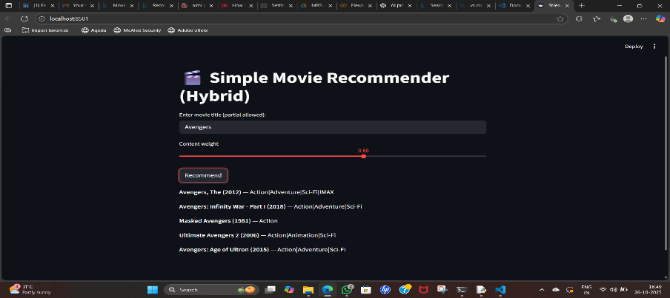
6. **Testing:**
   * Tested multiple movie inputs like Toy Story, Avengers, Star Wars
   * Verified recommendations change according to input and weight adjustments.

**6. Conclusion:**

The Movie Recommendation System demonstrates a simple yet effective way to recommend movies to users using a hybrid approach. The project showcases practical use of Python, TF-IDF, cosine similarity, and Streamlit for interactive web applications. This system can be further enhanced by adding user ratings, movie posters, and sentiment analysis to improve recommendation accuracy.